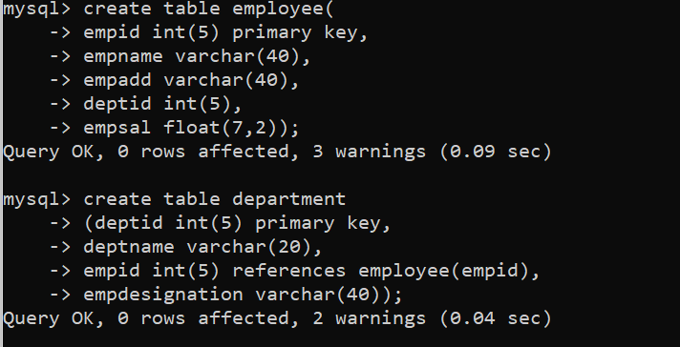

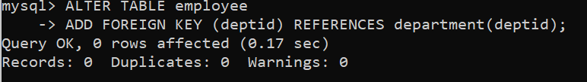

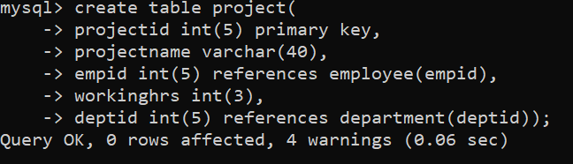

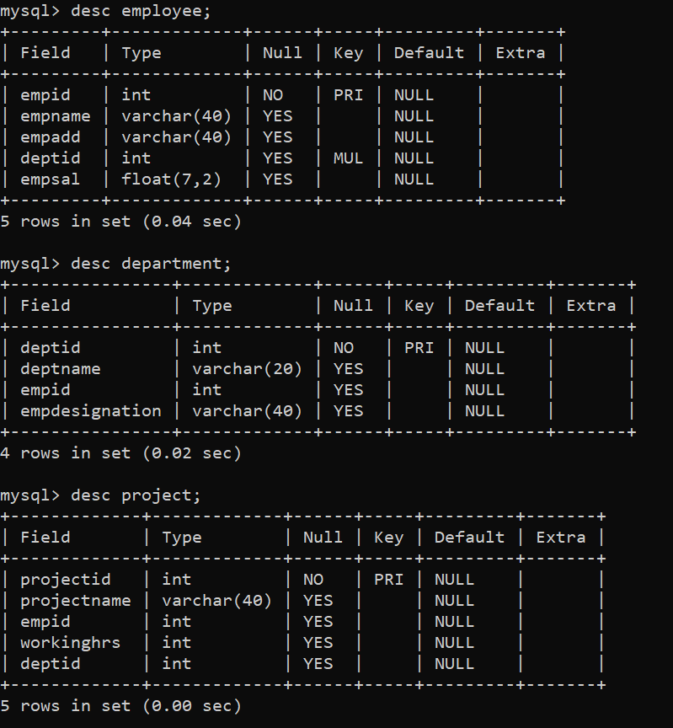

Questions

1. Find all the employees who work for department “HR”
2. Find total working hours for employee “Amit”
3. Find total working hours for employee “Amit” for project Machine Learning”
4. Find minimum and maximum salary of employee
5. Find the names of the employees whose 3rd character in name is “a”
6. List the name of employees whose name ends with “m”

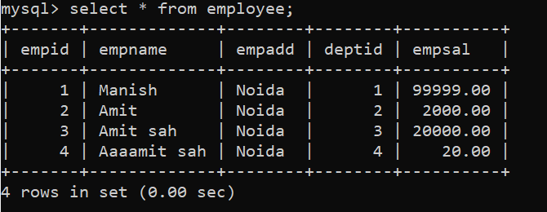

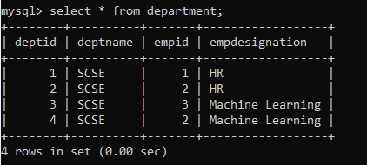

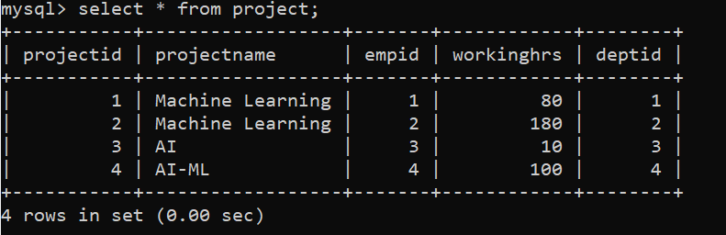

Answers:1

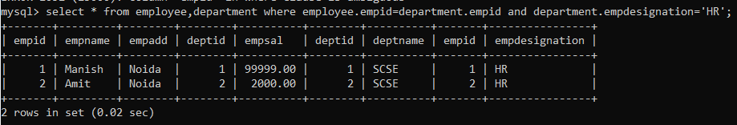

Answer:2

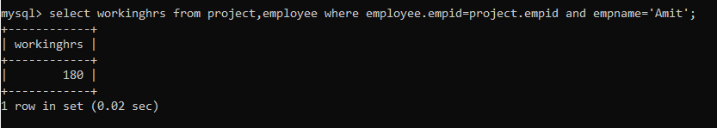

Answer:3

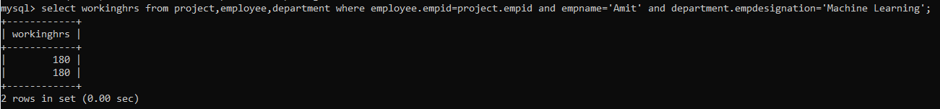

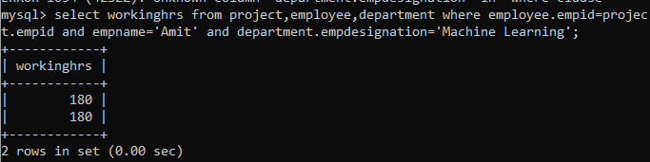

Answer:4

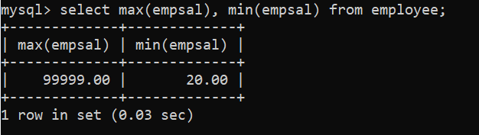

Answer:5

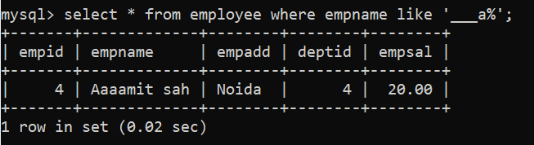

Answer:6

